Manuscript (Research/ review)

Title in original language in bold, size 14, centered.
Title translated into second language (English, or Spanish),
size 12, centered.
Author 1
Author 2
Author 3
1 last degree obtained or current studies, affiliated institution, city and country (applies to all authors).
Institutional email addresses (applies to all authors).
Each affiliation and email must be in one line and in size 11.
At the beginning of each affiliation and email will be the number or character in superscript that relates it to one or more author/s.
ABSTRACT
It should be aligned to the left; Verdana font, size 10; 1.15 line spacing. It must be a maximum of 350 words. It should offer a clear idea of the content of the article. The abstract should briefly describe the research objectives, methods, main results and discussion points, and conclusions. Avoid using abbreviations. The abstract should NOT contain references. It must have the following structure:

- Contextualization: The research field and the importance of the main area.
- Knowledge gap: Open questions, restrictions, limitations or the contribution to the existing knowledge gap in the article's field of study.
- Purpose: Description of the main objectives of the study.
- Methodology: Brief description of the research methods followed in the study.
- Results and conclusions: Brief description of the main results and conclusions obtained in the study.
Keywords: it is suggested to use a list of four to seven words, which should be presented in alphabetical order. Avoid using plural words and phrases. Do not repeat words that have already been used in the title. Ideally standardized words or descriptors from the AGROVOC, UNESCO Thesaurus and that are accepted by international databases.
RESUMEN (each manuscript requires an abstract in two different languages: Spanish or English)
Contextualización:
Vacío de conocimiento:
Propósito del estudio:
Metodología:
Resultados y conclusiones:
Palabras clave:
GRAPHIC SUMMARY (Required):
Description of results and conclusions obtained. It is a visual image of findings from the article submitted. It can be a figure designed for this purpose or a representative image of the research results and conclusions. It is necessary that all manuscripts include this figure in their manuscript.

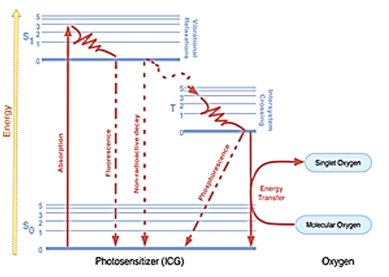

Note: APA rules on citing scientific articles, books, web pages, etc., must be followed in the submitted article.

1. INTRODUCTION
The introduction must initially explain the topic addressed with research that allows justifying the proposal of the problem; that is, it must have the necessary background to give an international context to the study carried out, clearly indicating the objectives of the research development.

Potentially, this section could include:
• The research field and the importance of the main area under study, presenting evidence of recent research and findings.
• The knowledge gap that the study seeks to fill, fully or partially, indicated through open questions, restrictions, and limitations of the selected research field.
• The importance of the study's proposals with respect to the knowledge gap, through evidence of its implications and applications in the research field.
• The main objective(s) of the study.
2. MATERIALS AND METHODS
The presentation must be clear, specific and sufficiently detailed so that the work can be reproduced. It must describe the procedures used in the research, including the experimental design and the statistically significant analysis of the data obtained by the study. This section should be structured by indicating the type of study, site, geoclimatic conditions, study site coordinates, study animals, laboratory methods, ethical aspects, etc. If a previously published method was used, only the reference should be indicated; in such cases, only relevant modifications should be included in the description.
3. RESULTS AND DISCUSSION
It corresponds to concise information of the research findings. The discussion should include comments based on the experience of the researcher, supported by documents such as journals, books and any document from a recognized institution that supports the conclusions made by the author(s). The information presented must follow a logical sequence in the text, tables and illustrations, according to the way in which methods were presented. Information should not be duplicated in text, tables or illustrations.
For the construction of the tables, without lines and columns, only one line that divides the axes is used, in single space, without vertical divisions or internal divisions. Units of the International System (IS) must be used. Abbreviations and acronyms should be explained as footnotes in each table. In any case, tables in a landscape format will be accepted. An example of the presentation of a table is:
Table 1. Example of the presentation of a table.

Sample number | Name | Surname | Department
M1 | Milton | Rodríguez | Cundinamarca
M2 | Alberto | Ruiz | Cundinamarca
M3 | Ricardo | Cadena | Cundinamarca
M4 | Oscar | Ríos Herrera | Cundinamarca
M5 | Carlos Felipe | Segura Medina | Cundinamarca
Source: adapted from XXXXX or authors (when the table is created by authors)

The category of figures includes graphics, images, photos, and each one of them must have its corresponding legend and source; if they are created by the authors themselves, please mention it. The abbreviations and acronyms must be explained in the figure legend. Figures must be submitted in .jpg, .gif or .png format and must have the necessary quality for publication (more than 1024 pixels). An example of a figure is:

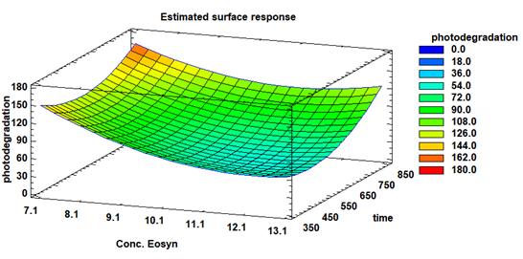
Figure 1. Figure title. Figure legend, verdana font size 9. Source: adapted from XXXXX or authors (when the table is created by authors)

All equations should be numbered next to it, cited in the text as (equation 1). It is suggested the equations to be developed in the Microsoft Word equation editor or through the Mathtype application. An example of an equation is:
(Equation 1)

4. CONCLUSIONS

It is the interpretation of the results obtained. Indicate the significant contributions of your study, limitations, advantages and possible applications. Please discuss your results in the light of international research and point out the major contribution of your research and environmental consequences. Highlight the conclusions of your study, as well as recommendations for future research.

AUTHOR'S CONTRIBUTION (required)

This section explains the contribution of each author to the article. Example:

First author: Methodology, research, data analysis, conceptualization, writing, original draft. Second author: Research, conceptualization, data analysis, writing, review and editing. Third author: Logistics, review and edition. Fourth author: data analysis, review and editing. Fifth author: Resource acquisition, project manager, supervision, conceptualization, writing, review and editing.

ACKNOWLEDGMENTS (required)

This section must be used to acknowledge those people or institutions that have made substantial contributions to the work or have provided research assistance (technical, financial, logistical, intellectual, among others). The acknowledgments should go as a separate section after the discussion and before the literature cited. Please include here the reference number of projects that made the study possible.

FUNDING (mandatory)

This section should indicate the funding institution(s) that provided financial support for the study, indicating the project code and the name of the call from which the resources used in the research presented here were obtained. If the study was not funded by any institution, the following words should be included in this section: Not applicable.

USE OF ARTIFICIAL INTELLIGENCE (mandatory)

Authors must indicate whether any type of artificial intelligence was used in the study and the manuscript sections in which it was used. The activities carried out by the authors with artificial intelligence must be explained in detail. It should be noted that data analysis and subsequent generation of new knowledge with the help of artificial intelligence are permitted, without affecting copyright. The use of text directly generated by artificial intelligence or image manipulation based on the use of artificial intelligence, is prohibited. In all cases, the use of artificial intelligence must be cited using APA standards. If artificial intelligence was not used in the study, the following words must be included in this section: Not applicable.

CONFLICTS OF INTEREST

Any conflicts of interest the authors may have with respect to the results, discussion, or conclusions presented in the manuscript must be disclosed in this section. Otherwise, in the absence of any conflict of interest, the following words must be included in this section: The authors declare that they have no conflicts of interest.

CITED LITERATURE

All those sources or authors that were cited in the body of the document should be included. An author who has not been cited, should never be referenced and vice versa. Please note that articles without references will not be accepted. A 60% of citations must come from research published in the last 10 years. This list is arranged in alphabetical and unnumbered order, and each must be indented. For the referencing of numbers or volumes of any publication, Arabic, and non-Roman numerals, should be used. The APA standards on bibliographic references of scientific articles, books, web pages, etc. must be followed. An example is:

Surname, A.A., Surname, B.B., and Surname, C. C. (Year). Article title. Name of the journal, volume (number), pp-pp. DOI XXXXXXXXX

ANNEXES

If you have any figures that occupy a full page (two pages) or additional relevant information from the study, which due to its length, is not possible to place within the main text, we recommend that you place it as an annex to the document (Annex 1, Annex 2, etc.). This figure will be linked in the web space where your article will be hosted and, in the case of the printed version, all information will be handled with a QR code. The annexes will be available on the web page of each article, in the link named “Annex”.

