Avian inventory through the use of mobile applications to strengthening aviturisming in el magdalena

Author 1 – Fanny Pinzón Candelario
Bachelor's degree in Biology, Master's degree in Environmental Engineering, PhD in Projects
ORCID: https://orcid.org/0000-0002-2082-2971
Email: fanny.pinzon@unad.edu.co

ABSTRACT
This article highlights the impact of emerging technologies on bird research and monitoring, with an emphasis on the use of mobile applications that enable species identification through photographs and calls. These tools have transformed fieldwork, benefiting both researchers and birdwatchers. The presentation focuses on an avian inventory conducted in two areas of the Magdalena Department: the Lower Toribio River Zone and the Minca Pozo Azul Zone. The paper also explores the potential of these apps to enrich biodiversity inventories, strengthen citizen science, and promote conservation.To develop this study, the transect and observation point methods were used. Species richness and abundance were recorded in both areas using specialized apps that capture images and bird calls for identification purposes.
The results show significant differences in species diversity and avian community structure between the two areas. The Minca Pozo Azul Zone had lower species richness (12 families) and a lower total number of individuals (52), compared to the Lower Toribio River Zone, which recorded 23 families and 67 individuals.The indices used included the Margalef, Shannon, and Simpson indices. The results indicated greater diversity in the Lower Toribio River Zone according to the Margalef and Shannon indices, while the Minca Pozo Azul Zone showed lower species dominance according to the Simpson index.

These findings suggest a richer avifauna in the Lower Toribio River Zone and a more equitable community structure in the Minca Pozo Azul Zone.

Keywords:
Diversity indices, birdwatching, citizen science, mobile applications.

- Introduction
Colombia, with more than 1,900 recorded bird species, ranks first in the world in bird diversity (Humboldt Institute, 2023). This richness represents not only an incalculable ecological value but also an opportunity for the development of birdwatching, environmental education, and scientific research. In this context, the use of technological tools has revolutionized the way bird monitoring and inventories are conducted. Mobile applications such as Merlin Bird ID, eBird, Xeno-Canto, BirdNET, and iNaturalist allow users to record observations, identify species, and share data in real time with both scientific and citizen communities. Bird inventories are essential tools for conservation, as they provide reliable and replicable information on the composition and structure of avian communities. This, in turn, allows for the assessment of ecosystem conservation status and enables comparisons (Villareal et al., 2004). This study focuses on comparing the avifauna of two areas with different ecological characteristics, assessing species diversity and abundance in both, and determining how habitat differences influence avian community structure: the Lower Toribio River Zone and the Minca Pozo Azul Zone. Both areas represent key habitats within the Sierra Nevada de Santa Marta, but differ in altitude, vegetation cover, and degree of human intervention. The results contribute to a better understanding of regional biodiversity and offer valuable input for future conservation strategies and citizen participation in science.
- Background and Related Work
The study of birdlife in the lower Toribio River basin and the Minca Pozo Azul area responds to the growing concern for biodiversity conservation and the sustainable development o
f ecotourism. The research is framed within community ecology, which analyzes the composition and structure of species in a given ecosystem (Begon, Townsend, & Harper, 2006). In particular, bird diversity is a key indicator of environmental health and ecosystem functionality (Bibby, Jones, & Marsden, 1998).
Nature tourism, and birdwatching in particular, has been widely studied as a sustainable development strategy that generates economic benefits and promotes environmental conservation (Buckley, 2009). However, it has also been documented that the unplanned growth of tourism infrastructure can negatively impact natural habitats, affecting the distribution and abundance of species (Steven, Morrison, & Castley, 2015).
To assess avifaunal diversity in the study areas, ecological indices such as the Margalef, Shannon, and Simpson indices were used, which allow estimating species richness and evenness in the ecosystem (Magurran, 2004). These indicators have been applied in various studies on biodiversity and conservation, demonstrating their effectiveness in environmental impact assessment and natural resource management (Gotelli & Chao, 2013).
Species identification was carried out through direct observation and the use of digital tools such as Merlin Bird ID and Picture Bird, which have significantly improved the accuracy of ornithological research (Sullivan et al., 2014). Previous studies have shown that these applications contribute to citizen science and facilitate data collection in hard-to-reach areas (Bonney et al., 2009).
The most notable applications currently used for bird inventory are:
- Merlin Bird ID: Developed by the Cornell Lab of Ornithology, this application allows bird identification through photographs or song recordings. Its artificial intelligence is powered by a global database that is constantly expanding thanks to user contributions (Cornell Lab of Ornithology, 2024).

- eBird: Also managed by the Cornell Lab, eBird is one of the most widely used platforms in the world for recording bird observations. Users can upload georeferenced checklists, allowing for the generation of distribution maps and analysis of migratory patterns (Sullivan et al., 2009).

- Xeno-Canto: This collaborative platform stores recordings of bird songs from around the world, allowing for the comparison and study of vocalizations across species and regions (Xeno-Canto Foundation, 2023).

- BirdNET: Based on neural networks, BirdNET analyzes bird songs captured by a phone's microphone to provide automatic identification. It is especially useful in dense habitats where visual observation is limited (Kahl et al., 2021). iNaturalist: Although not limited to birds, its automatic recognition technology and global community of experts make iNaturalist a powerful tool for participatory biodiversity monitoring (iNaturalist, 2024).
- Picture Bird: This app uses image recognition to identify birds from user-taken photographs. It is especially useful for beginners, as it offers descriptions, habitats, and typical behaviors of the detected species. Although its database is less robust than that of Merlin or eBird, it is an accessible and educational tool that complements participatory monitoring efforts (Picture Bird, 2024).
- Research Methodology
3.1 Study Area
The study was conducted on the northern flank of the Sierra Nevada de Santa Marta, in two of its basins: the Gaira River basin near Minca (Pozo Azul) in the Santa Marta district, and the lower Toribio River basin in the municipality of Ciénaga.

The lower Toribio River basin is characterized by its lower altitude, predominantly tropical dry forest vegetation, and greater human intervention. The second zone, Minca Pozo Azul, located at a higher altitude, features a more conserved tropical dry forest and less human pressure.

3.2 Bird Inventory Method
Bird records were made through direct observation during sampling periods between February and April 2023, and July and September 2023, applying the methodology established by Wunderle (1994) and Ralph et al. (1996), which seeks to cover the largest possible area among several researchers.
To conduct the bird inventory, two main methods were used: transects and observation points. These methods provide a representative sample of the birdlife present in each area and are widely used in ornithological studies.
Individual sightings were conducted through free walks along transects, accumulating a total of 60 hours of observation per area on alternating days between morning (6:00–10:00) and afternoon (3:00–6:00) according to the guidelines established by Ralph, 1981, considering these are the times when birds are most active.

3.3 Transects
Three transect lines, each 350 meters long, were located at each sampling site. To avoid double counting, the transects were separated by at least 150–200 meters (González García 2013).
The start and end of each Transect Line (TL) were marked with a red marker, making them easier to identify. Subsequently, each transect line was slowly covered to record the species found in each habitat (González García 2013), at a speed of approximately 1 km/h. It was also taken into account whether the bird was recorded in the canopy of a tree or bush, on a trunk, on the ground, or in the water. Along each transect, all birds observed and heard were recorded, noting the species, number of individuals, and their behavior.

3.4 Observation and Counting Points
Six fixed counting and observation points were located in each sampling area along each transect, identified by yellow caps, so that censuses could be conducted at the same sites throughout all sampling periods. The minimum distance between points was 250 m (Ralph et al. 1996, Mac Gregor-Fors et al. 2010), and to avoid the edge effect, the minimum distance between a CP and the boundary of a different habitat was 100 m (Ralph et al. 1996, Bibby et al. 1998). Continuous observations were conducted at these CPs for 15 minutes. All observed birds were recorded at these points, thus complementing the data obtained from the transects. In addition to the above, to complement the list of families, sound recordings of vocalizations obtained during the tours were included. For this purpose, the methodology established in the Manual of Methods for the Development of Biodiversity Inventories of the Alexander Von Humboldt Institute, Chapter 5 Birds, was used, which proposes to carry out observations and recordings simultaneously and use the techniques of Brutney and Grotke (2000) proposed in the article "Techniques for the recording of tropical birds". It is important to highlight that the recorded vocalizations were first labeled and processed with the help of two Pro Tools programs and the Audiolab App in order to eliminate ambient sounds and noises that could intervene in the contrast and identification of bird vocalizations. These recordings were compared with 3 mobile applications, for bird identification Merlin, eBird and Picture Bird, where sound fragments were introduced, in order to identify the bird and compare it with what was observed.

4.RESULTS
4.1 Diversity and Abundance
The results showed significant differences in species richness and abundance between the two study areas. In the Minca Pozo Azul Zone, a total of 52 individuals belonging to 12 families were recorded, while in the Lower Toribio River Zone, 67 individuals belonging to 23 families were recorded.
Table 1 Shows a summary of the results obtained for each order and family in both areas.
Table 1
Summary of results for bird richness and abundance in the two study areas.
ORDER | FAMILY | AREA 1 Minca | AREA 2 Toribio
Paseriformes | Passeridae | 1 | 0
Paseriformes | Eurylaimidae | 1 | 0
Paseriformes | Corvidae | 2 | 1
Paseriformes | Troglodyidae | 2 | 1
Paseriformes | Icteridae | 1 | 5
Paseriformes | Cisticolidae | 0 | 7
Paseriformes | Parulidae | 0 | 2
Paseriformes | Thraupidae | 0 | 2
Paseriformes | Cardinalidae | 0 | 1
Paseriformes | Icteridae | 0 | 1
Paseriformes | Pirangas | 0 | 5
Paseriformes | Coerebidae | 0 | 3
Paseriformes | Turdidae | 0 | 1
Apodiformes | Trochilidae | 0 | 1
Caprimulgiformes | Steatornithdae | 12 | 7
Columbiformes | Columbidae | 1 | 0
Psittacidae | Psittaciformes | 6 | 6
Trogoniformes | Trogonidae-quetzal | 23 | 13
Strigiformes | Strigidae | 1 | 0
Accipitriformes | Tytonidae | 1 | 1
Pelecaniformes | Accipitridae | 1 | 2
Pelecaniformes | Threskiornithidae | 0 | 2
Pelecaniformes | Ardeidae | 0 | 1
Pelecaniformes | Ardeidae | 0 | 1
Pelecaniformes | Pelecanidae | 0 | 1
Tinaniformes | Tinadmidae | 0 | 1
Piciformes | Ramphastidae | 0 | 1
TOTAL |  | 52 | 67

Nota: Elaboración propia

Figure 1 shows that the order richness was higher in the Toribio River compared to the Minca River. The Psittacidae order stands out in both areas, including parrots, parakeets, conures, and macaws, which have a characteristically curved beak shape.
Figure 1
Order richness in the Minca and Toribio areas.
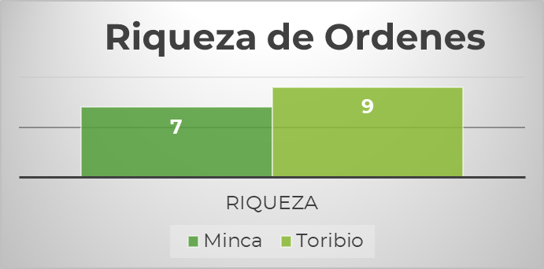
Note: Prepared by the authors.

Regarding family richness, we can see in Figure 2 that this was also higher in the Toribio River area, since it exceeded that of Minca by 216%, which could be associated with the diverse habitat conditions found in the lower part of the Toribio River where the mouth of the river meets the Caribbean Sea, so some specimens of coastal birds from the Pelecaniformes family could be seen, which include herons, pelicans, among others.

Figura 2

Wealth of families in the Minca and Toribio areas.
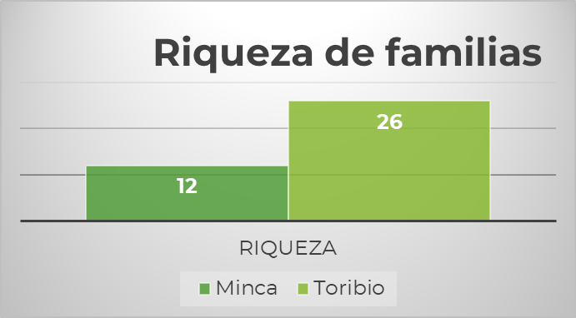
Note: Prepared by the authors.

On the other hand, the abundance of individuals found in each zone was established by order and family. Figures 3 and 4 show the abundance for the Minca Zone by order and family level. The most abundant was the family Piscitaciformes of the order Pscitacidae, with 23 individuals identified.

Figura 3 y 4
Abundance of Orders and Families in the Minca Area
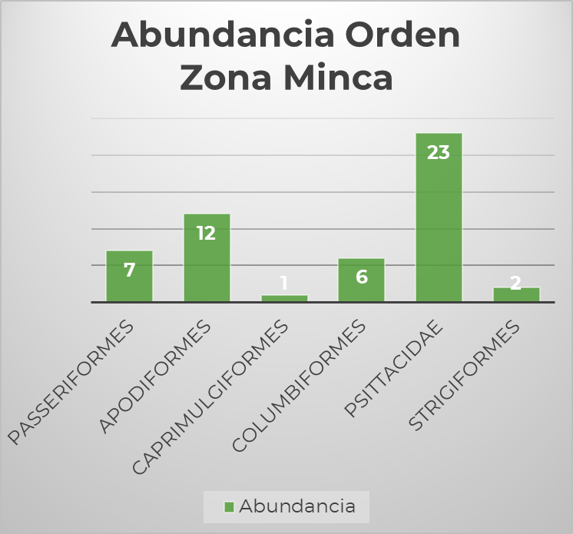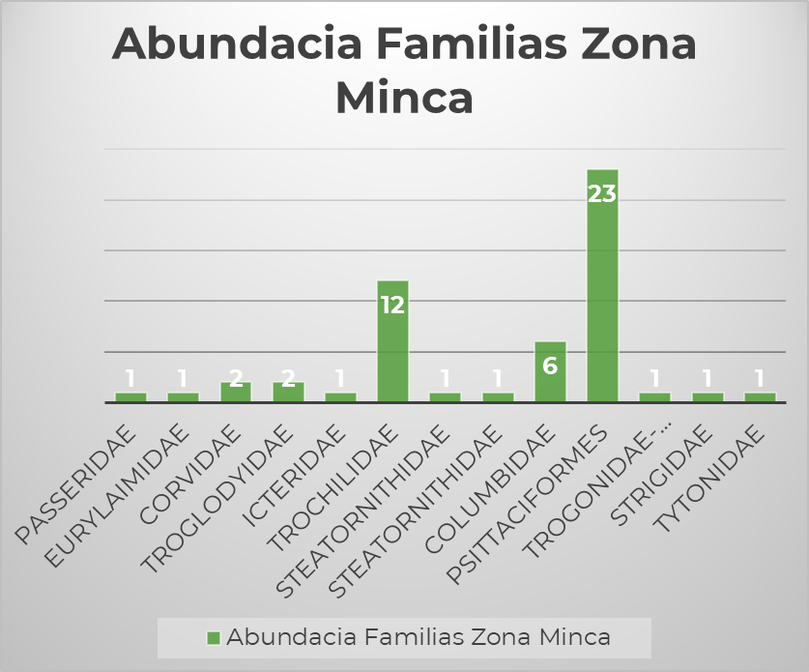
Note: Prepared by the authors.
In the case of the lower Toribio Basin Zone, the most abundant family was the Pscitaciformes (parrots and parakeets) with 13 individuals, while in the case of the Orders, the most abundant were the Passeriformes (commonly called birds or songbirds) with 30 individuals, as can be seen in Figures 5 and 6.
Figure 5
Abundance of Orders in the Toribio Zone
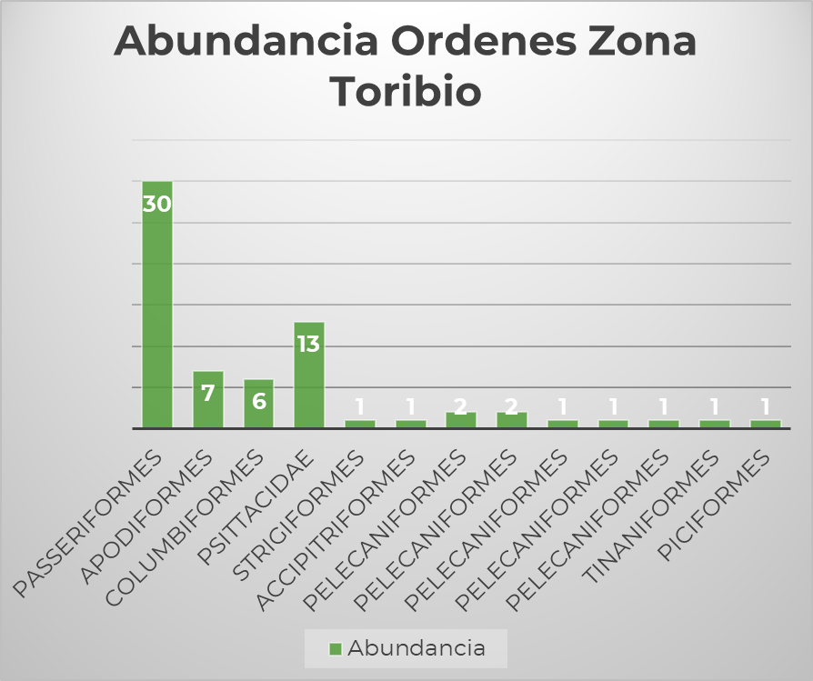
Note: Prepared by the authors.

Figura 6

Abundance of Familys in the Toribio Zone
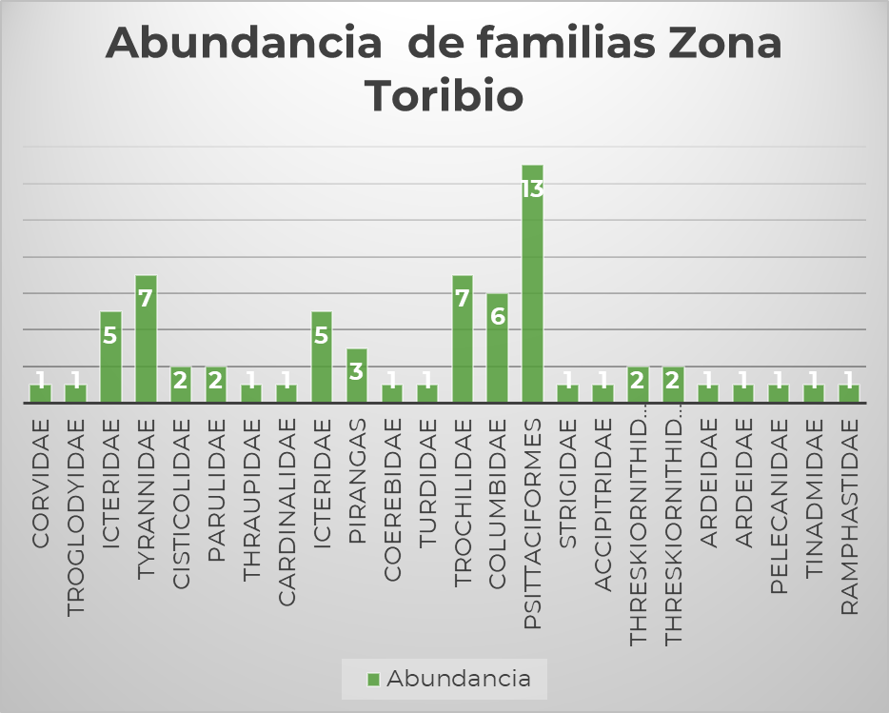
Note: Prepared by the authors.
Taking individuals from both areas, the five most abundant orders were, as can be seen in Figure 7, first, Paceriformes with 34%, Pscythidae with 33%, Apodiformes with 19%, Columbiniformes with 12%, and Pelicaniformes with 5%, as can be seen in Figure 7.
Figure 7
Most abundant orders in the study áreas
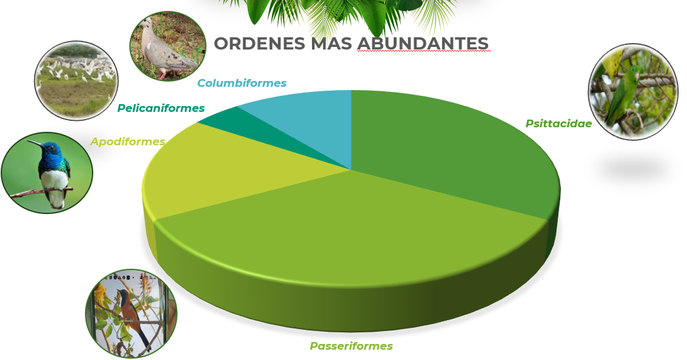
Note: Prepared by the authors.

The diversity indices reflected a greater diversity in the Lower Zone of the Toribio River, with a Shannon Index of 2.182 and a Simpson Index of 0.913, compared to the Minca Pozo Azul Zone, which presented a Shannon Index of 1.731 and a Simpson Index of 0.732 as can be seen in Table 2. These results suggest a greater heterogeneity in the avian community of the Lower Zone of the Toribio River.

Tabla 2

Diversity Indices
Diversity Indices Alfa | Minca Zona | Toribio Zona
Margaleff Diversity Index | 2,78 | 5,23
Diversity Alfa Shanonn | 1,73 | 2,18
Simpson Dominance | 0,268 | 0,087
Simpson Diversity | 0,732 | 0,913
Note: Prepared by the authors.
5.Discussion and Conclusions
Las diferencias en la riqueza de especies y la diversidad entre las dos zonas estudiadas pueden estar relacionadas con las diferencias en la estructura del hábitat y el grado de intervención humana. La mayor riqueza de especies en la Zona Baja del Río Toribio puede estar asociada con la diversidad de hábitats presentes en esta zona, que incluye tanto áreas boscosas como zonas abiertas, ofreciendo una variedad de recursos para las aves.
Por otro lado, la menor diversidad observada en la Zona Minca Pozo Azul podría estar influenciada por su mayor altitud y menor grado de intervención humana, lo que podría limitar la presencia de especies generalistas y favorecer a aquellas adaptadas a condiciones más específicas.
La importancia de la diversidad alfa, medida a través del Índice de Shannon, radica en su capacidad para reflejar la equitatividad y riqueza de especies en una comunidad. En este sentido, la Zona Baja del Río Toribio no solo presentó una mayor riqueza de especies, sino también una mayor equitatividad, lo que sugiere una comunidad aviar más equilibrada.
El presente estudio revela diferencias significativas en la avifauna de dos zonas ecológicas del Departamento de Santa Marta. La Zona Baja del Río Toribio, con una mayor riqueza de especies y diversidad, destaca como un área de alta importancia para la conservación de la avifauna en la región. Por otro lado, la Zona Minca Pozo Azul, aunque con menor diversidad, también presenta un valor ecológico significativo, especialmente por la presencia de especies adaptadas a altitudes mayores.
Estos resultados subrayan la necesidad de continuar realizando inventarios de biodiversidad en diferentes zonas de la Sierra Nevada de Santa Marta, para mejorar nuestra comprensión de la distribución y estado de conservación de las especies en esta región. Además, estos estudios son fundamentales para el diseño de estrategias de conservación que consideren las particularidades de cada zona ecológica.
El uso de aplicaciones móviles para el inventario de aves representa un avance significativo en la forma de hacer ciencia de campo. Al democratizar el acceso al conocimiento ornitológico, estas herramientas promueven una cultura de observación responsable y contribuyen a la conservación de la biodiversidad. Se recomienda a instituciones educativas y grupos de investigación incorporar estas apps en sus proyectos y capacitar a nuevos usuarios en su uso ético y responsable.

REFERENCIAS BIBLIOGRÁFICAS

Begon, M., Townsend, C. R., & Harper, J. L. (2006). Ecology: From individuals to ecosystems. Blackwell Publishing.

Bibby, C., Burgess, N., Hill, D., & Mustoe, S. (2000). Bird Census Techniques. Academic Press.

Bonney, R., Cooper, C. B., Dickinson, J., Kelling, S., Phillips, T., Rosenberg, K. V., & Shirk, J. (2009). Citizen science: A developing tool for expanding science knowledge and scientific literacy. BioScience, 59(11), 977-984.

Buckley, R. (2009). Ecotourism: Principles and practices. CABI.

Cornell Lab of Ornithology. (2024). Merlin Bird ID. https://merlin.allaboutbirds.org/

Gotelli, N. J., & Chao, A. (2013). Measuring and estimating species richness, species diversity, and biotic similarity from sampling data. Encyclopedia of Biodiversity, 5, 195-211.

Hilty, S. L., & Brown, W. L. (1986). A Guide to the Birds of Colombia. Princeton University Press.
iNaturalist. (2024). Homepage. https://www.inaturalist.org/
Instituto Humboldt. (2023). Listado de aves de Colombia. https://humboldt.org.co/

Kahl, S., Wood, C. M., Eibl, M., & Klinck, H. (2021). BirdNET: A deep learning solution for bird identification using audio recordings. Ecological Informatics, 61, 101236.

Krüger, O. (2005). The role of ecotourism in conservation: Panacea or Pandora’s box? Biodiversity & Conservation, 14, 579-600.

Magurran, A. E. (2004). Measuring biological diversity. Blackwell Science.

Ralph, C.J., G.R. Geupel, P. Pyle, T.E. Martin, D.F. de Sante y B. Milá. (1996). Manual de métodos de campo para el monitoreo de aves terrestres. General Technical Report, PSW– GTR–159, Pacific Southwest Research Station, Forest Services, U.S. Department of Agriculture, Albany, California

Steven, R., Morrison, C., & Castley, J. G. (2015). Birdwatching and avitourism: A global review of research into its participant markets, distribution and impacts. Environmental Management, 56(2), 459-475.

Sullivan, B. L., Wood, C. L., Iliff, M. J., Bonney, R. E., Fink, D., & Kelling, S. (2014). eBird: A citizen-based bird observation network in the biological sciences. Biological Conservation, 169, 31-40.

Villarreal H., M. Álvarez, S. Córdoba, F. Escobar, G. Fagua, F. GAST, H. Mendoza, Μ.Ospina y A.M. Umaña. (2004). Manual de métodos para el desarrollo de inventarios de biodiversidad. Programa de Inventarios de Biodiversidad. Instituto de Investigación de Recursos Biológicos Alexander von Humboldt. Bogotá, Colombia. 236 р.

Wunderle, J.M., Jr. (1994). Métodos para contar aves terrestres del Caribe. General Technical Report SO–100. U.S. Department of Agriculture, Forest Service, Southern Forest Experiment Station, New Orleans, Louisiana

Sullivan, B. L., Wood, C. L., Iliff, M. J., Bonney, R. E., Fink, D., & Kelling, S. (2009). eBird: A citizen-based bird observation network in the biological sciences. Biological Conservation, 142(10), 2282-2292.
Xeno-Canto Foundation. (2023). Xeno-Canto bird sound archive. https://www.xeno-canto.org/
Picture Bird. (2024). Picture Bird: Bird Identifier. https://www.picturebirdai.com/

