Engineering active packaging with MOFs: functional nanomaterials against resistant foodborne pathogens
Desarrollo de envases activos con MOFs: nanomateriales funcionales contra patógenos resistentes de origen alimentario

Author 1 - Paula Andrea Méndez Morales
Chemist, PhD in Chemical Sciences
Grupo - Laboratorio de Investigación y Desarrollo Agroalimentario – LIDA, Escuela de Ciencias Básicas, Tecnología e Ingeniería – ECBTI, Universidad Nacional Abierta y a Distancia – UNAD, Calle 14 Sur 14-23, Bogotá D.C., Colombia
ORCID https://orcid.org/0000-0002-7153-1787
email: paula.mendez@unad.edu.co

Author 2 - Laura María Reyes Méndez
Agro-industrial Engineer, PhD in Food Engineering.
Grupo - Laboratorio de Investigación y Desarrollo Agroalimentario – LIDA, Escuela de Ciencias Básicas, Tecnología e Ingeniería – ECBTI, Universidad Nacional Abierta y a Distancia – UNAD, Calle 14 Sur 14-23, Bogotá D.C., Colombia
ORCID https://orcid.org/0000-0002-3782-8747
email: laura.reyes@unad.edu.co

Author 3 - Leidy Johanna Gómez Sampedro
Food Engineer, MSc. in Pharmaceutical Sciences: Food, PhD in Biotechnology
Grupo - Laboratorio de Investigación y Desarrollo Agroalimentario – LIDA, Escuela de Ciencias Básicas, Tecnología e Ingeniería – ECBTI, Universidad Nacional Abierta y a Distancia – UNAD, Calle 14 Sur 14-23, Bogotá D.C., Colombia
ORCID https://orcid.org/0000-0001-9078-7051/
email: leidyj.gomez@unad.edu.co

Author 4– Eduart Andrés Gutiérrez Pineda
Chemist, PhD in Engineering.
Grupo de Investigación GIA, Escuela de Ciencias Básicas, Tecnología e Ingeniería, Universidad Nacional Abierta y a Distancia, Calle 14 Sur 14-23, Bogotá D.C., Colombia.
Soft Matter Nanotechnology Group, Center for Cooperative Research in Biomaterials (CIC biomaGUNE), Basque Research and Technology Alliance (BRTA), Paseo de Miramon 194, 20014 Donostia – San Sebastian, Spain
ORCID https://orcid.org/0000-0002-8651-9828
email: eduart.gutierrez@unad.edu.co

ABSTRACT.
The present work consolidates a review of the state of the art on the potential of metal-organic frameworks (MOFs) as functional nanomaterials incorporated into active packaging systems for the inactivation of multidrug-resistant (MDR) pathogens associated with food. Methodologically, a systematic review of recent scientific literature was conducted, using a descriptive and retrospective approach based on theoretical methods such as analytical-synthetic, historical-logical, inductive-deductive, and systemic-structural, as well as a co-occurrence analysis of keywords using VOSviewer, delimited to the period 2016-2026. The bibliometric analysis allowed for the examination of synthesis routes (solvothermal, sonochemical, and green cyclodextrin-MOFs) and incorporation techniques into polymeric matrices (solvent casting); highlighting that nanostructures with high porosity and surface area can encapsulate bioactive agents such as carvacrol or thymol, achieving a controlled release sensitive to pH or humidity stimuli; which enables them to exert bactericidal action through the gradual release of metal ions and the generation of reactive oxygen species (ROS). It is concluded that MOFs, especially those based on cyclodextrins (CD-MOFs), represent revolutionary platforms for food safety. However, there are still limitations such as aqueous instability and scalability.

Keywords.
Food; bacteria; biofilm; packaging; inactivation; organometallic; nanotechnology; pathogens.

INTRODUCTION
Ensuring food safety regarding pathogens remains an ongoing global challenge, as various diseases are transmitted through contaminated food, creating a problem for public health and the socio-economic sphere [1], [2]. According to the World Health Organization, more than 600 million people suffer from diseases caused by contaminated food annually, resulting in approximately 420,000 deaths. Microbiological contamination not only threatens human health but also causes substantial economic losses due to productivity loss, product recalls, and the erosion of consumer confidence [1], [3], [4].
Pathogen resistance to antimicrobial agents has raised additional concern [5]. Strains of Salmonella spp., Escherichia coli, and Listeria monocytogenes have increasingly acquired resistance mechanisms due to the overuse and misuse of antibiotics in human medicine and agriculture [2].
Conventional antimicrobials and passive packaging solutions are current strategies under study that provide evident limitations [6]. Broad spectrum antimicrobial treatments are typically ineffective in controlling major spoilage causing and multidrug resistant (MDR) bacteria [6]. Also, the direct addition of synthetic preservatives into food may cause loss of flavor quality, significant health hazards and increased development of bacteria resistance [7]. Conventional passive packaging simply functions as an inert barrier and generally does not provide the desired features to actively control the package atmosphere or to suppress microbial growth under dynamic environmental conditions [3].
To overcome these issues, there is a strong demand for enhanced active antimicrobial packaging systems. Active packaging aims to interact with the food or the headspace by releasing bioactive chemicals, e.g., essential oils or metal ions, to suppress the undesired bacterial and fungal growth, compared to passive containers. But a technical hurdle persists in generating a prolonged and regulated release of these chemicals [1], [7].
This brings us to a fundamental scientific question: can metal-organic frameworks (MOFs) get a development as functional platforms to inactivate resistant pathogens? MOFs are a family of crystalline hybrid organic-inorganic materials with high porosity, variable pore diameters and remarkable surface areas [6]. Their “building block” method enables rational creation of frameworks that can contain antimicrobial chemicals for triggered release or exploit intrinsic bactericidal features such as the formation of reactive oxygen species (ROS) and destruction of microbial membranes [3].
The objective of this literature review is to analyze the potential of MOFs as functional nanomaterials incorporated into active packaging systems for the inactivation of resistant foodborne pathogens. By exploring their structural tunability and diverse antimicrobial mechanisms, this study evaluates how MOF-based technologies have revolutionized chemical research into applications for the food industry.

THEORETICAL-CONCEPTUAL FRAMEWORK
Before going into the construction of this literature review, it is vital to know about viruses, food packaging and metal-organic frameworks (MOFs); therefore, first provide a brief definition and context in this section. A pathogen is a microorganism that can cause diseases. Most sources of information pertain to bacteria, fungi, viruses and parasites. Research on foodborne pathogenic bacteria such as Salmonella spp., Escherichia coli, Listeria monocytogenes and Campylobacter spp., which are responsible for outbreaks and diseases arising from the ingestion of contaminated foodstuffs, has been conducted within the framework of food safety and security. Before discussing some of the most studied diseases, it is relevant to differentiate between gram-positive and gram-negative bacteria, as this is the basis for many antibacterial drugs or nanosystems. The basic difference is in the shape of their cell envelope and their physiology that affects their degree of permeability and sensitivity to anti-microbial medicines. Escherichia coli or Campylobacter are gram-negative bacteria that contain an extra outer membrane, which acts as a dense protective barrier. The membrane contains protein channels called porins, which control the entry of chemicals into the cell. For example, beta-lactams and fluoroquinolones are antibiotic classes that gram-negative bacteria can avoid by reducing the expression of these porins, so preventing the medications from entering and acting on their target areas inside the cell. The outer membrane is absent in gram-positive bacteria such as Staphylococcus aureus or Listeria monocytogenes [5], [8].
The cell wall is also another difference in its structure. The bacterial envelope has a peptidoglycan structure and a phospholipid bilayer in its cell membrane [9]. Both structures are severely damaged and collapse during exposure to chemicals generating oxidative stress or ROS [8], [9]. However, the physical differences in the cell wall make gram negative bacteria much more resistant to physical touch and different chemical treatments [1], [8].
Gram-negative bacteria also have an outer membrane and often have stronger antioxidant defense systems, which lead to distinct susceptibility and defensive mechanisms. Many active antimicrobial drugs, such as photosensitive systems based on riboflavin or curcumin, are more bactericidal to gram-positive than to gram-negative pathogens. These structural differences are major obstacles in the design of nanomaterials for active packaging, as functional platforms to overcome the outer membrane barrier in multidrug-resistant gram-negative bacteria are necessary [8].
To understand the significance of these studies, it is important to show some events related to these infections. Escherichia coli is a gram-negative bacterium, potentially a harmless commensal but also has dangerous strains such as the Shiga toxin-producing which can cause severe intestinal infections. Central Europe, predominantly Germany, in 2011, the severity of the strain to adhere to the intestine, produce a toxin and kept resistance resulted in over 4000 infections and 54 fatalities. On the other hand, Salmonella spp. is a gram-negative bacterium that causes salmonellosis, one of the most reported foodborne zoonoses globally. In 2019, there were more than 300 reported outbreaks of multidrug-resistant Salmonella in the EU, causing over 2,500 hospitalizations [2], [5].
Thus, other pathogens may be found, for example, Listeria monocytogenes, a gram-positive bacterium capable of multiplying at refrigeration temperatures—posing a significant risk to food products. Staphylococcus aureus is a gram-positive bacterium that generates extremely resistant biofilms and heat-stable enterotoxins. It is a common disease and can easily infect meat and dairy products during processing. Campylobacter spp a microaerophilic gram-negative bacterium, with C. jejuni and C. coli being the major causative agents of human gastroenteritis that are mainly related to the ingestion of undercooked poultry [2], [4].
In this context, food packaging films are important in food safety as they serve as a protective physical barrier that protects the products from external contamination, microbiological intrusion, and adverse environmental variables during storage, distribution, and transportation. However, when infections can colonize the surface of the packaging or the food itself, generating biofilms that sustain their existence, the efficacy of these films is severely hampered [4]. Figure 1 summarizes the issue of pathogens and the potential use of MOFs to combat them. Therefore, we will now discuss the basic concepts of these metal-organic frameworks.
Figure 1. Conceptual illustration of resistant foodborne pathogens and the potential use of MOF-type nanomaterials for the development of active packaging.
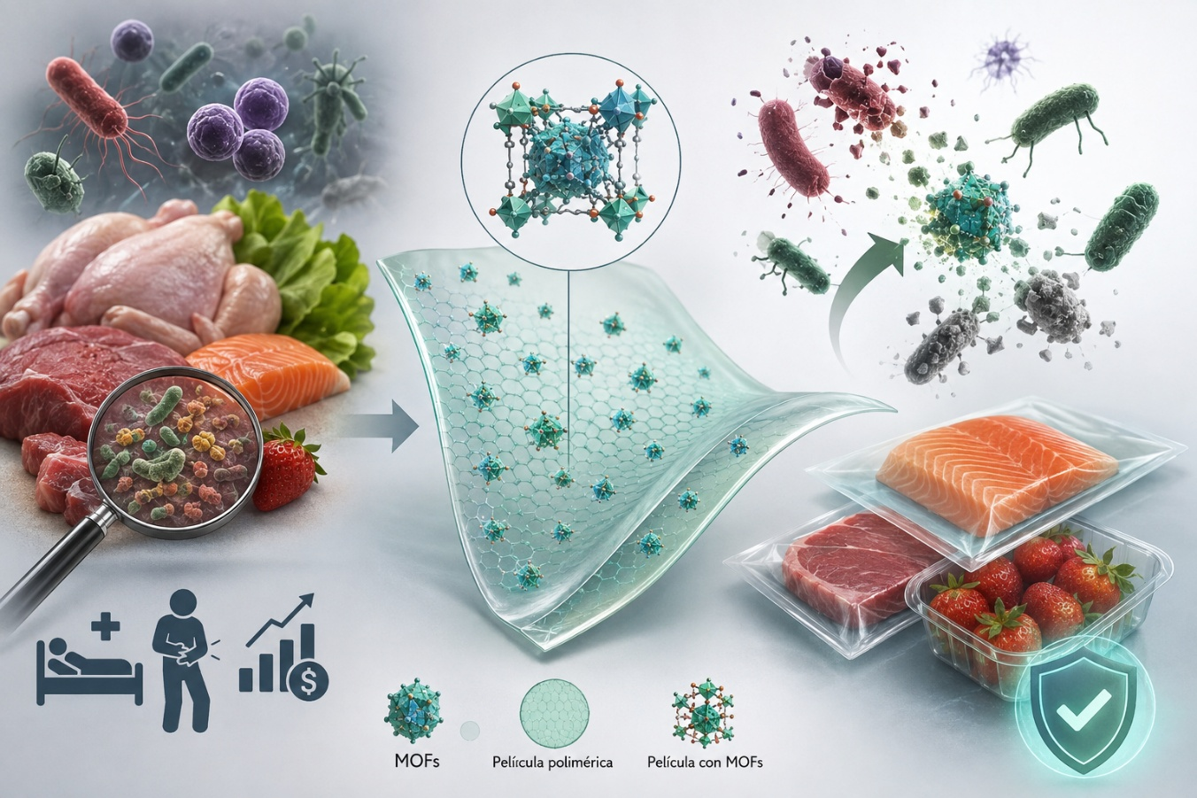
Source: imagen obtained from ChatGPT.

Serious disadvantages of traditional materials in the packaging industry restrict their applicability and sustainability. First, synthetic plastics made from petroleum take centuries to decompose and contribute to a large build-up of non-biodegradable garbage in landfills and oceans. Second, the ecological alternatives as the use of biodegradable and compostable biopolymers present poor mechanical properties and high permeability to water vapor, oxygen and microbes, which drastically reduces their capacity to preserve food for long periods [1].
Given these restrictions, MOFs provide a disruptive and ubiquitous nanotechnology platform to develop high-efficiency antimicrobial active packaging [3]. MOFs are characterized by porosity and crystallinity properties, which are made of metal nodes linked by coordinated organic ligands. Their unique modular construction endows them with remarkable features like as extraordinarily high specific surface area, nano-scale tunable porosities and excellent structural and functional flexibility [3], [7]. Only in 2025 were these hybrids structures recognized for their unique properties, through the Nobel Prize in Chemistry awarded to Richard Robson, Susumu Kitagawa and Omar Yaghi.

MOFs as functional nanomaterials in packaging films can overcome significant shortcomings of existing techniques through multiple mechanisms:
- Encapsulation and stabilization of active compounds: The high porosity of MOFs provides an ideal protective environment for hosting and stabilizing essential oils such as carvacrol and thymol, unstable phytopharmaceuticals which protecting them from thermal decomposition and premature volatilization [1], freshness indicators like anthocyanins a pH-sensitive compounds; and others [10].
- Smart and Controlled Release Systems: MOFs enable the tuning of diffusion kinetics in response to specific environmental stimuli, instead of a huge and uncontrolled release [9]. In humid conditions that encourage microbial growth, for instance, water molecules can enter the pores of the MOFs and displace the antibiotic in a competitive fashion, leading to regulated release as a function of relative humidity [3], [8], [9]. Similarly, pH-sensitive stability MOFs that disassemble and release their bactericidal load in response to the acidity changes due to the metabolism and growth of infections [9].
- Multimodal Enhancement of Film Properties: The use of them as nanofillers in the polymeric matrix of the packaging leads to the production of mixed matrix membranes and the MOFs nanoparticles prevent the direct diffusion of gases. This pushes the molecules of the oxygen and water vapor to diffuse along a more challenging channel, strongly decreasing the water vapor permeability (WVP) and the gas transfer rates. Simultaneously, MOFs enhance the tensile strength, Young’s modules and thermal stability of biodegradable films dramatically, owing to the creation of three-dimensional networks of hydrogen bonds and electrostatic interactions with the underlying polymer [3], [6].
- Intrinsic and synergistic microbial inactivation: Many MOFs possess a strong biocidal activity through the slow and controlled release of antimicrobial metal ions such as silver, cobalt, zinc, or copper, that disrupt bacterial membranes, or through the production of ROS induced by photodynamic or photothermal activation under mild light irradiation [1], [3].
Thus, MOF-assisted active packaging engineering not only maintains the freshness attributes of highly perishable foods such as fruits, vegetables and meats by delaying senescence and weight loss, but also provides a highly effective surface disinfection methodology against foodborne pathogens, thus decreasing the reliance on conventional chemical treatments.

METHODOLOGY
The present research was developed through a qualitative bibliographic review complemented with a bibliometric analysis, aiming to analyze the potential of MOFs as functional nanomaterials incorporated in active packaging systems for the inactivation of foodborne resistant pathogens.
The review utilized historical-logical, inductive-deductive, and analytical-synthetic methodologies to investigate the evolution and application of MOFs. The historical-logical approach traced the use of the MOFs in chemical research and functional materials for food packaging. The inductive-deductive method assessed experimental results to detect patterns in structural properties or processes, and effectiveness against pathogens. The analytical-synthetic method categorized information on MOF types, incorporation techniques, microbial inactivation mechanisms, target microorganisms, and packaging applications, integrating significant advances, limitations, and future perspectives in the field [11].
Figure 2 illustrates the methodology employed to conduct this literature review. The first and second stages consolidate the information search. The search for scientific information was conducted in specialist databases, such as Scopus, ScienceDirect and Web of Science. The search was performed using combinations of descriptors relating to "metal-organic frameworks", "MOFs", "active packaging", "food packaging", "antimicrobial packaging", "polymeric films", "foodborne pathogens", "antimicrobial resistance" and "pathogen inactivation", without Boolean operators due to the search method was designed to discover studies directly connected to the antibacterial activity of MOFs.
In the third stage, documents were selected by reading titles, abstracts and full contents in a gradual process. Only original research publications and reviews published in indexed journals that provided important information on MOFs, antimicrobial mechanisms, foodborne pathogens, microbial resistance, and active packaging methods were selected.
Figure 2. Description of the methodology developed.
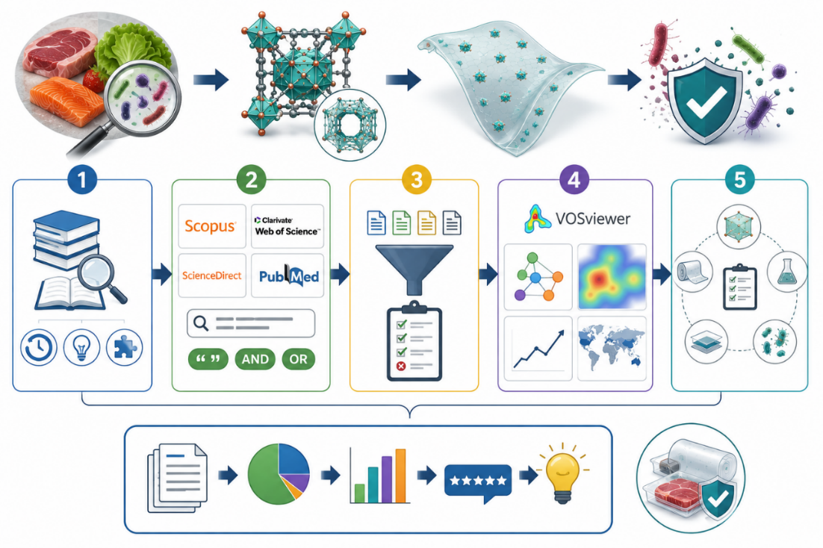
Source: imagen obtained from ChatGPT.
In addition to the documentary study, bibliometric analysis was performed with VOSviewer 1.6.21 version, and the relationships existing in the selected scientific literature were visualized. Using this technique, we studied the co-occurrence of keywords to generate network maps to discover the main thematic clusters, trends, and conceptual links within a study [12].
Finally, the selected studies were organized and analyzed in thematic categories such as type and composition of MOF, polymeric matrix used, strategy of incorporation of the nanomaterial, mechanisms of microbial inactivation, pathogens evaluated, and application in active packaging systems.

RESULTS AND DISCUSSION
The final combination of words “metal organic frameworks for active packaging” allowed to obtain most results in Web of Science, 294. Figure 3 presents the network map obtained by co-occurrence of keywords. Four main groups were identifie., which named like blue, red, yellow and green. The blue group was related to Metal-Organic Frameworks in which was observed to be the primary one, correlating with the yellow and red groups; the latter are associated with the early stages of MOF research, a period focused on studying physicochemical properties for electrochemical and energy applications. Within this correlation, key terms were identified on the right-hand side, such as nanoparticles and adsorption, which correlate with hydrogen storage, gas adsorption, carbon dioxide, catalysis, coordination polymers, capture, drug delivery, electrochemical synthesis, storage, porous coordination polymers, nanocrystals, thin films, membranes, growth, surface, size, room-temperature synthesis, hydrothermal synthesis, porous material, gas separation, and MOF.
The information related to these groups converges between the years 2009 to 2020. The interest in inorganic-organic hybrid compounds has its origins in 1830 with the report of the salt of Zeise, the first organometallic compound of platinum. During the 20th century, chemistry advanced toward multidimensional structures (1D, 2D, and 3D) driven by the search for intrinsic porosity. Inorganic aluminosilicate zeolites were of great industrial interest, but their ability to incorporate transition metals homogeneously was very limited. Thus, the introduction of bridging organic ligands formally gave rise to MOFs, creating a fusion between molecular chemistry and solid-state physics [13].
The methodologies to synthesize MOFs have evolved significantly to reduce time, costs, and environmental impact. Traditional methods were established with techniques such as solvothermal/hydrothermal, in which closed reactors at high pressure and temperature are used [1], [9]. However, their disadvantages lie in extended reaction times (hours to days), and the use of toxic solvents such as dimethylformamide (DMF) [9]. The fast and high-tech methods include microwave-assisted synthesis, in which electromagnetic energy is converted into heat directly on the reactants, reducing synthesis times from hours to minutes and producing uniform nanocrystals [9]. Sono-chemical synthesis or ultrasound, which employs ultrasound waves to generate acoustic cavitation, that is, localized heat and pressure bubbles in microseconds, which accelerate nucleation under ambient conditions. And microfluidics, which allows continuous flow through micrometric channels for precise control of morphology in a matter of seconds [9]. Finally, the green synthesis and cyclodextrin-based frameworks (CD-MOFs); this arises to overcome toxicity limitations in food and medicine. Natural oligosaccharides derived from starch (cyclodextrins) and safe cations like potassium are used, achieving edible, renewable, and biodegradable materials [8].
Figure 3. VOSviewer analysis by co-occurrence of keywords based on results from Web of Science.
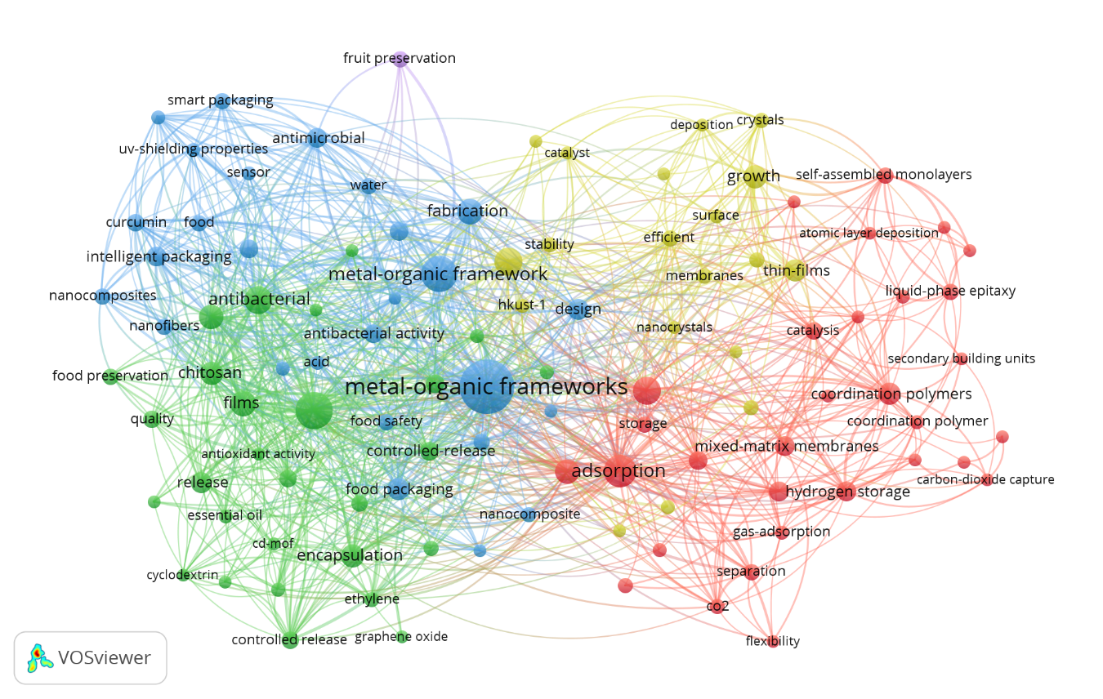

Beyond its synthesis, the applications of MOFs have developed from gas physics to direct interactions with complex biological systems. They were utilized for gas storage and separation in their first stage, due to their huge surface area, generally from 1000 to 10000 m²/g. These structures were intended to store hydrogen and methane and to selectively absorb carbon dioxide from combustion streams [14].
In the intermediary phase these were utilized in catalysis and sensors, respectively. Their metal nodes operate as spatially isolated single-site catalysts, imitating the behavior of metalloenzymes due to their weak ligand fields, which enables their usage in heterogeneous catalysis [13]. In biosensors, they have been investigated as luminescent, colorimetric or surface-enhanced Raman scattering (SERS) platforms for the real-time detection of levels of toxins, heavy metals, pesticides or infections [1].
Finally, in the advanced phase, there are applications in biomedicine and food packaging. In medicine, the biocompatibility and degradability of some frameworks have been exploited for controlled medication delivery and targeting [14], [15]. In active and intelligent food packaging, a present trend, they are used to be incorporated into polymeric films to block harmful gases, act as ethylene absorbers to delay ripening or for controlled release of antimicrobials such as essential oils or carvacrol, activated by stimuli such as moisture. These also work as smart labels that irreversibly change color when reacting with ammonia or volatile amines produced during rotting of meats or seafood by integrating substances such as anthocyanins [3], [9].
The bibliometric analysis also evidenced that China is the country with the most studies about this topic, and the research into the application of MOFs in food is recent. The green group was related to active packaging, the topic of interest to analyze the MOFs application as functional nanomaterials against resistant foodborne pathogens. In this case, the correlation was identified with key terms such as antibacterial, chitosan, films, antioxidant activity, antimicrobial activity, controlled release, release, encapsulation, ethylene, graphene oxide, cyclodextrin, essential oil, quality, food preservation, CD-MOF, shelf-life extension, oxidation, extract, acid, food safety, composites, degradation and removal, Figure 4A. In turn, this group correlates with the blue one, which presents two main clusters that establish co-occurrence with keywords such as nanofibers, nanocomposites, extract, acid, antibacterial activity, composite, metal-organic frameworks, performance, fabrication, water, antimicrobial, sensor. Starch, food, curcumin, intelligent packaging, uv-shielding properties, smart packaging, ammonia-sensitive, food safety, polymer, cellulose, and design, Figure 4B.

Figure 4. Enlargement of the left side of the general co-occurrence map obtained with VOSviewer: A) Green cluster and B) Blue cluster.
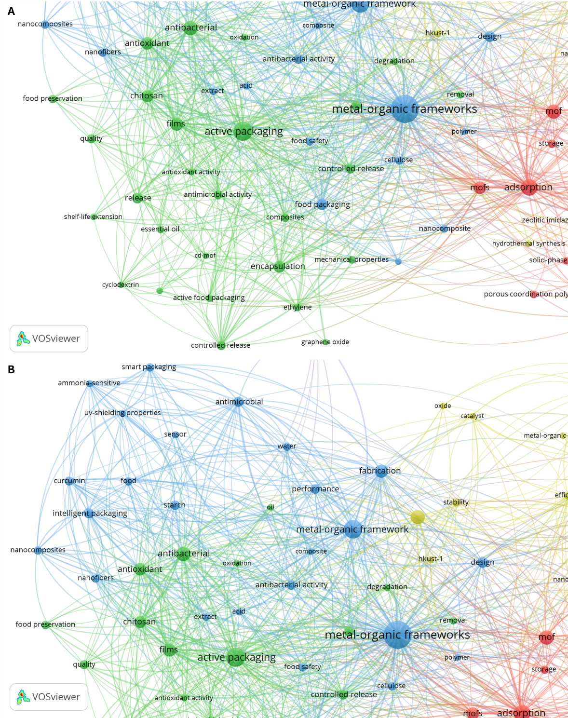
The most highly cited articles were selected and arranged chronologically for analysis. Table 1 presents the MOF analyzed, citations and co-citation map of the studies selected and the publication year.

Table 1. Articles selected for the analysis of MOFs applications in packaging as functional nanomaterials against resistant foodborne pathogens.
MOF analyzed | Publication year/Citations and co-citation map
Cruciform petal-like zeolite imidazole framework-8 (ZIF-8) [16]  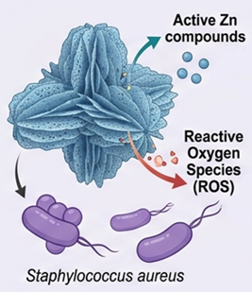 | 2022/38  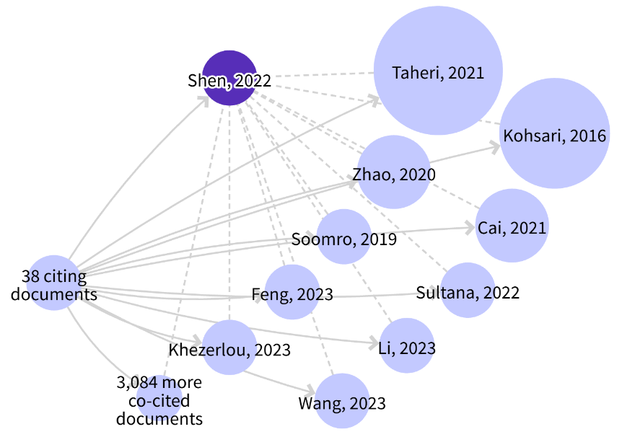
Copper-based metal-organic frameworks (Cu-MOFs) [17]  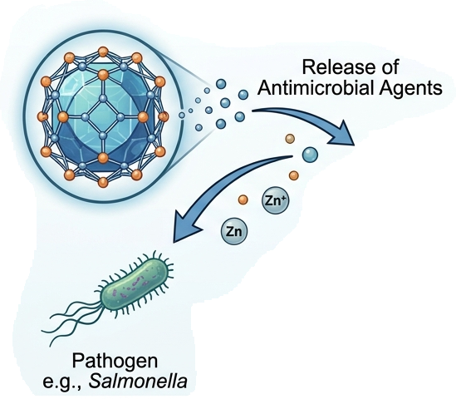 | 2023/118  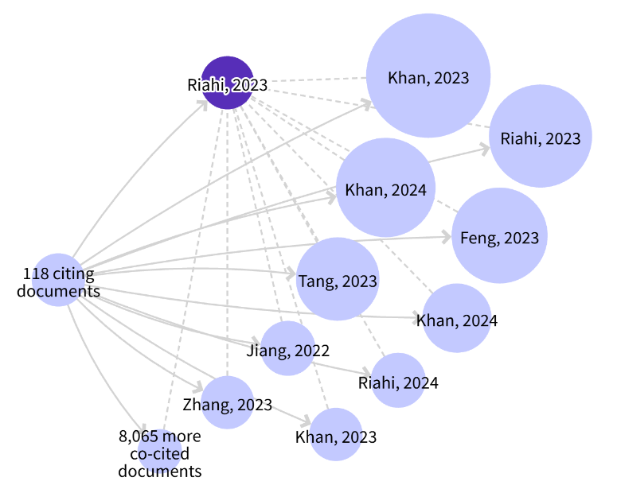
Metal-organic frameworks ZIF-8 (Zn-MOFs) [18]  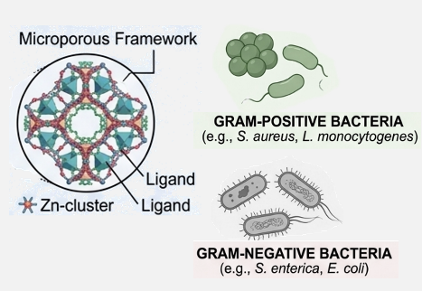 | 2023/103  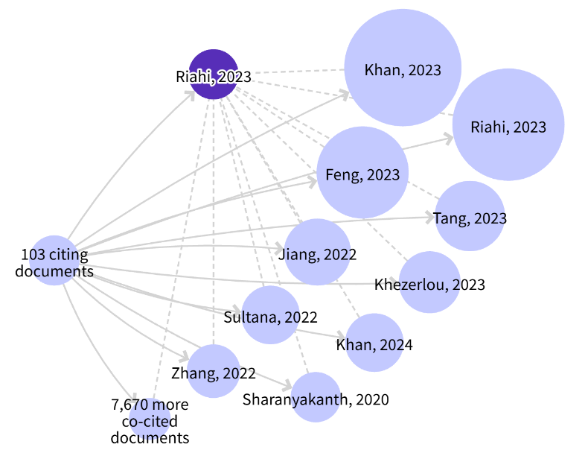
Cu-MOF [19]  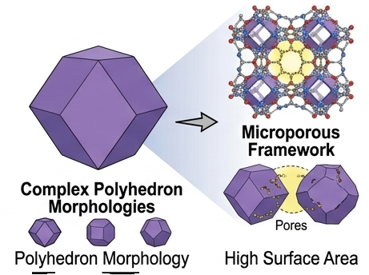 | 2024/63  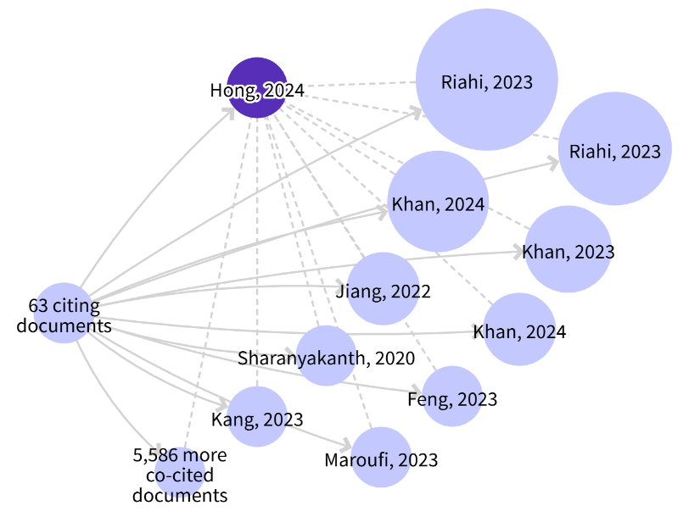
Cyclodextrin Metal-organic Frameworks (γ-CD-MOFs) loaded with citral (CA) (MOF@CA) and coated with cellulose acetate butyrate (CAB) (C-MOF@CA) [20]  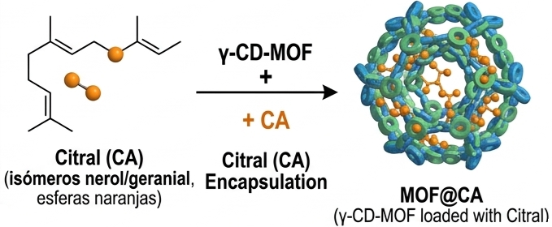 | 2025/15  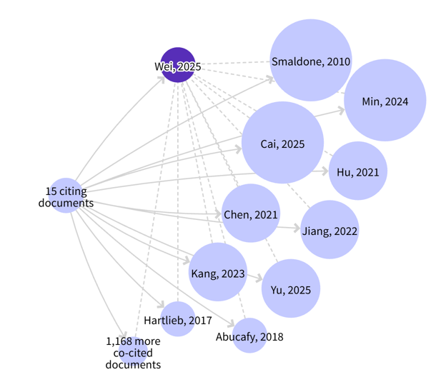
Cyclodextrin-based metal–organic frameworks (γ-CD-MOFs) [21]  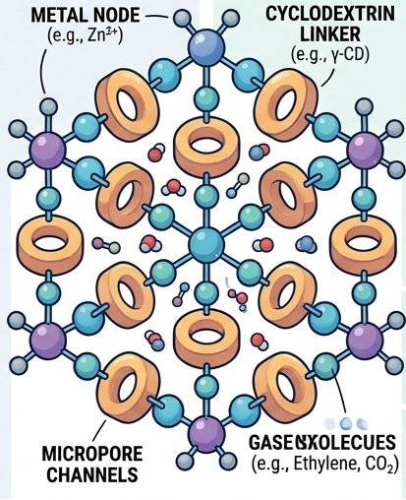 | 2026/7  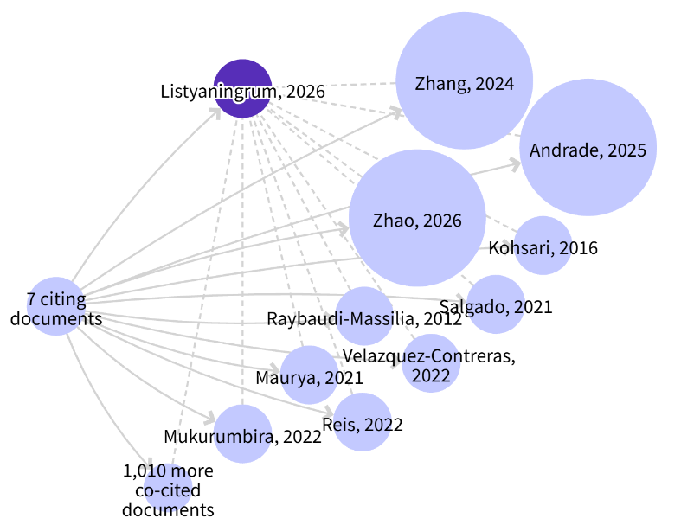
Source: Organized by the authors using co-citation maps obtained from Web of Science. Representations of the MOF structures were generated using Gemini indicating the morphology and composition of the MOF.

The co-citation analysis demonstrates a link between the temporality of the publications and the creation of the main clusters of authors within study. Older references, for example, Smaldone (2010) and Kohsari (2016), are found to maintain a relevant presence as conceptual frameworks in actual research. A stage of knowledge consolidation is observed starting in 2020, given the greater density of relationships among authors, particularly around works such as those by Taheri (2021), Zhao (2020), and Cai (2021). Similarly, authors with publications between 2023 and 2026, such as Khan, Riahi, Feng, Zhang, Andrade, and Zhao, show a growing concentration of co-citations among recent studies, evidencing the development of specialized and dynamic research. Overall, these patterns indicate a temporal relationship in the development of the network, where fundamental works are still co-cited together with recent studies, although the newest publications tend to cluster and consolidate new lines of inquiry.
According to the studies selected in Table 1, the MOFs application was analyzed according to the type and composition of MOF, polymeric film, nanomaterial incorporation into the film, microbial inactivation mechanism, pathogen studied and application. Figure 5 provides a summarized illustration based on the analysis presented below.
Figure 5. A representation summarizing the analysis of the most widely studied MOFs and their incorporation into polymer matrices to inactivate pathogens through their intrinsic properties and encapsulated active compounds.
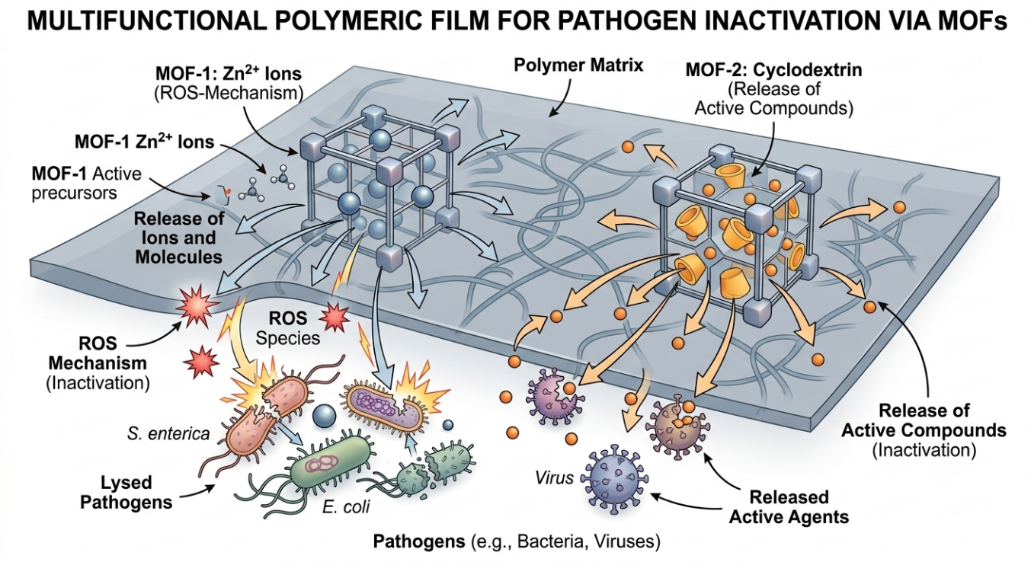
Source: imagen obtained from Gemini.

Type and composition of MOFs
Research indicates two different classes of MOFs used in food packaging: transition metal-based MOFs and cyclodextrin-based MOFs (CD-MOFs).
In the first class were identified ZIF-8, a Zn-MOF made of zinc and 2-methylimidazole [16], and Cu-MOF [18], a coordinated structure composed of copper cations and 1,3,5-benzenetricarboxylic acid [17], [19]. These materials are highlighted by their good crystalline characteristics, adjustable porosities and large surface areas [17], [18]. Furthermore, the morphology of these structures has been reported to be dependent on the synthesis method. For example, conventional ZIF-8 has a dodecahedral morphology, whereas the variants synthesized in the aqueous phase can produce cruciform architectures resembling petals (P-ZIF-8) [16]. Cu-MOFs can self-assemble into three-dimensional flower-shaped crystals consisting of ultrathin nanosheets [18].
In the second category, CD-MOFs are an example of "edible MOFs", a sustainable and biosecure approach that uses natural products such as cyclodextrins (α-, β- or γ-CD) linked to non-toxic metal cations of the alkali group such as potassium or sodium. This avoids the use of heavy transition metals or toxic synthetic ligands, yielding alternatives in line with rules for direct contact with food [20], [21].
Polymer matrices for the film
The most recurrent polymeric matrix is marine-derived gelatin, due to its outstanding capacity to produce films, transparency and biocompatibility. Binary polymeric mixes are proposed to decrease the problems related to mechanical or barrier properties of pure gelatin [16], [18], [19]. Thus, the authors some strategies:
- Gelatin/polyvinyl alcohol (Gel/PVA) provides a cohesive and dense polymeric structure to host pH indicators and active MOFs [17].
- Gelatin/Pullulan (Gel/Pull) in which the mechanical strength of the films is got by interaction between the carboxyl groups of gelatin and the hydroxyls of pullulan through hydrogen bonds, keeping the flexibility [19].
- Chitosan (CS) is a cationic polysaccharide with inherent barrier and antibacterial properties and good compatibility with hydrophobic reinforcements and bioactive chemicals, such as citral [20].
- Common textile fibers are treated with polydopamine (PDA) and PVA for better adhesion and water resistance [16].
The incorporation of MOFs into these matrices has a significant effect on their physical properties, due to these act as mechanical reinforcing agents by filling the free volumes of the polymer chains, hindering the motion of molecules and creating dense networks of hydrogen bonds, which increases the tensile strength and decreases the water vapor permeability (WVP) through the creation of a more convoluted diffusion pathway for gaseous molecules [17], [18], [19].
Methods of incorporation of the nanomaterial
The stability of the film and the release profile of the actives depend directly on the incorporation method of the nanomaterial. The main technique is solvent casting, where the MOF is directly combined with the film-forming polymer prior to a drying process. For fibrous materials, successive immersion with coupling agents like polydopamine (PDA) is favored and its functionalization enables solid anchoring of MOFs on the soft fiber surfaces [16], [20].
The moisture sensitivity of MOFs, especially CD-MOFs and ZIF-8, is identified as a challenge by these studies, because their metal–ligand coordination bonds are prone to hydrolysis and readily collapse upon contact with water or high humidity, leading to premature and uncontrolled release of the encapsulated agent [20], [21]. To overcome this vulnerability, innovative strategies of surface modification or interfacial encapsulation are introduced:
- Interfacial coating of MOFs with hydrophobic biopolymer such as cellulose acetate butyrate (CAB). The non-polar interactions and hydrogen bonds between CAB and the MOF surface form a protective physical barrier which stabilizes the MOF and keeps it crystalline in water for over 15 days [20].
- Chemical cross-linking of CD-MOFs with agents such as diphenyl carbonate that replaces portion of the weak coordination links with strong covalent bonds [20], [21].
Microbial inactivation mechanisms
Packaging methods developed with MOFs are acting in their antibacterial activity through three basic molecular pathways:
- Generation of ROS (Reactive Oxygen Species): MOFs such as ZIF-8 can act as photocatalysts under visible light through processes of charge transfer between ligand-metal, which generate photoelectrons on the surface to react with the surrounding oxygen and water, which produces peroxide, hydroxyl radicals and superoxide anions. Oxidizing species infiltrate through the bacterial envelopes, leading to lipid peroxidation, DNA damage, and inactivation of cellular proteins [16], [18].
- Active Metal Cations (Zn²⁺, Cu²⁺) Release: The released ions from MOF structure are adsorbed on bacterial cell wall, changing membrane potential and leading to physical deformation of the cell envelope [19]. The ions produced from the MOF structure are adsorbed on the bacterial cell wall, changing the membrane potential and inducing physical deformation of the cell envelope. This results in cell lysis and leakage of important cytoplasmic nutrients [17], [18]. The metal ions impede cellular respiratory enzymes, denature proteins, and stimulate formation of intracellular endogenous ROS [17]. Interestingly, the cruciform ZIF-8 synthesized in water is more thermally and structurally instable than the conventional dodecahedral ZIF-8, dissociating more rapidly in solution and releasing a much higher concentration of active zinc ions [16].
- Controlled release of volatile bioactive compounds: The MOF's porous cavities encapsulate the essential oils or hydrophobic volatiles such as citral, cinnamaldehyde, thymol, carvacrol, or eugenol, and prevent their premature evaporation [19]. The ambient humidity of the food stimulates the progressive release of these substances which permeabilize and damage the lipid membrane of bacteria and fungus, preventing cellular metabolism and microbial replication for a long time [20].
Differential sensitivity and tested pathogens
The antimicrobial activity of the films was analyzed against pathogens such as gram-positive bacteria: Staphylococcus aureus and Listeria monocytogenes, and gram-negative bacteria: Escherichia coli and Salmonella enterica [16]. A systematic differential susceptibility is seen between the two bacterial groups, with gram-positive bacteria being consistently more susceptible to physical invasion of MOFs, penetration of metal cations such as Zn²⁺ or Cu²⁺, and ROS; it is due to the structure of their cell wall [16]. Gram-positive bacteria do not have a complicated exterior lipid membrane, as Gram-negative bacteria do, and have a porous peptidoglycan envelope that allows direct diffusion of the MOF nanoparticles and cations into the intracellular region. The outer membrane of gram-negative bacteria, however, is a selective barrier which greatly limits the admission of these substances [16]. But the use of large volatile hydrophobic broad-spectrum compounds such as cinnamon aldehyde or citral, which balances out this difference and achieves high inactivation rates of up to 96% - 97% in both the bacterial cell types [20].
Application to active and intelligent packaging systems
The articles demonstrate how the physicochemical and biological properties of MOFs are successfully transferred to the preservation of real meals through several practical application methodologies:
- Preservation of products (Fresh-cut): The chitosan film combined with γ-CD-MOF modified with CAB and loaded with citral considerably slows down the oxidative browning, significantly reduced weight loss due to transpiration and controls the proliferation of microorganisms on the surface of apples and lotus roots during 7 days of storage [20].
- Packaging of fresh meat (beef and pork): The application of Gel/Pull films filled with CEO@MOF blocks, which can absorb 99.5% of UV radiation, prolongs the loss of juices and moisture and stabilizes the pH of beef in the commercial acceptability standard (<6.2) for more than 16 days [19]. Also, movies that release eugenol enhance the shelf-life of pork by 100% [21].
- Climacteric and sensitive fruits: Gelatin films containing Zn-MOFs delay senescence and minimize softening in cherry tomatoes stored for 16 days at 10 °C by reducing the activity of pectin methylesterase and polygalacturonase, the enzymes that destroy the fruit wall [18]. Conversely, CD-MOF sachets releasing hexanal inhibit mango ripening while films containing carvacrol reduce mold in strawberries [19].
- Smart packaging (active and intelligent): The Cu-MOFs and anthocyanins loaded on the Gel/PVA film has multifunctionality, where Cu-MOFs can prevent bacterial growth and lipid browning and as a porous adsorbent to concentrate volatile nitrogenous decomposition compounds (ammonia and amines) from the shrimp [17].
For the above reasons, the incorporation of MOFs into biodegradable polymer matrices is a revolutionary advance in the development of smart packaging, achieving not only the optimization of the mechanical and barrier properties of the materials, but also the new antimicrobial, antioxidant and real-time colorimetric monitoring properties. The regulated release of bioactive chemicals and metal cations from these porous nanostructures is highly efficient against foodborne pathogens such as E. coli, S. aureus and L. monocytogenes, which extends the shelf life and freshness of perishable products. Therefore, this combination between nanotechnology and sustainable biopolymers paves a very promising approach for the future generation of biosecure, efficient and low environmental impact packaging technologies.

CONCLUSIONS
Metal-organic frameworks are promising functional nanomaterials for active packaging systems due to their high surface area, adjustable porosity and adaptability to improve the thermal, mechanical and barrier stability of polymeric films. Their nanocarrier capability enables the effective inactivation of multidrug resistant (MDR) food pathogens by regulated and slow release of encapsulated bioactive substances such as essential oils and other compounds endowed with antibacterial activity. Moreover, the inherent toxicity of their metallic nodes to bacterial membranes and the formation of deadly oxidative stress by reactive oxygen species (ROS) production or photothermal effects under mild light contribute to a more potent action against pathogens. The development of MOFs revealed that the use of nanostructures based on metal ions opened the door to the design of “green” and very biocompatible alternatives, such as the CD-MOFs derived from edible cyclodextrins, providing a very promising and safe alternative for direct contact with food compared to the MOFs prepared with heavy metals or ligands of petroleum origin. The aqueous instability of some structures, the high cost of raw materials and the complexity of the industrial scale-up are challenges that still need to be addressed. In addition, development of green synthesis methodologies that do not use toxic organic solvents is needed, and the toxicological evaluation should be performed thoroughly to accurately determine the migration limits of ions and ligands in real food matrices under dynamic storage conditions.

Acknowledgments: The authors acknowledge the project EXT17ECBTIZCORI2026 SUSNAMU – “Sustainable Nanocellulose and Amyloid-Based Materials for Biodegradable Packaging and Smart Agricultural Applications” for funding, and the Universidad Nacional Abierta y a Distancia for their cooperation. Additionally, the authors declare: “During the preparation of this literature review, the authors used Quillbot to check for correct English usage, ChatGPT and Gemini were used to create illustrative images. The authors have reviewed and edited the output and assume full responsibility for the content of this publication.”

Conflicts of interest: the authors declare no conflicts of interest regarding the review conducted.

REFERENCES
[1] S. Jafarzadeh et al., “Improving the functionality of biodegradable food packaging materials via porous nanomaterials,” Jul. 01, 2023, John Wiley and Sons Inc. doi: 10.1111/1541-4337.13164.
[2] A. Elbehiry et al., “Microbial Food Safety and Antimicrobial Resistance in Foods: A Dual Threat to Public Health,” 2025, doi: 10.3390/microorganisms.
[3] W. Jiang et al., “Multifunctional Metal–Organic Frameworks for Enhancing Food Safety and Quality: A Comprehensive Review,” Dec. 01, 2025, Multidisciplinary Digital Publishing Institute (MDPI). doi: 10.3390/foods14234111.
[4] J. B. Barbosa, “Microbial Contamination and Food Safety (Volume I),” Jan. 01, 2025, Multidisciplinary Digital Publishing Institute (MDPI). doi: 10.3390/biology14010059.
[5] O. V. Ifedinezi et al., “Environmental Antimicrobial Resistance: Implications for Food Safety and Public Health,” Nov. 01, 2024, Multidisciplinary Digital Publishing Institute (MDPI). doi: 10.3390/antibiotics13111087.
[6] M. J. Khan, M. R. Islam, F. Hafeez, C. He, J. Zhang, and Y. Xianyu, “Multifunctional Mg-MOF-74@Carvacrol/Chitin nanofiber-based nanocomposite film for enhanced food packaging,” Chemical Engineering Journal, vol. 527, Jan. 2026, doi: 10.1016/j.cej.2025.169666.
[7] J. Yang, J. W. Rhim, S. M. Jafari, and W. Zhang, “Photoactivated multimodal antimicrobial biopolymer films: synergies, innovations, and sustainable intelligent food packaging,” Adv. Compos. Hybrid Mater., vol. 8, no. 5, Oct. 2025, doi: 10.1007/s42114-025-01438-3.
[8] R. Abedi-Firoozjah et al., “Unlocking the Potential of Cyclodextrin/Metal–Organic Frameworks in Food Packaging Systems: An Exclusive Review on the Latest Trends,” Jun. 01, 2025, Springer. doi: 10.1007/s11947-025-03769-x.
[9] Y. Kang et al., “Review: Metal–organic framework design strategies and applications in food packaging,” Jun. 01, 2026, Springer. doi: 10.1007/s10853-026-12793-x.
[10] S. S. Rosales-Murillo et al., “Anthocyanin-Loaded Polymers as Promising Nature-Based, Responsive, and Bioactive Materials,” Jan. 01, 2024, Multidisciplinary Digital Publishing Institute (MDPI). doi: 10.3390/polym16010163.
[11] L. E. P. Enrique, A. M. Martín, and E. A. H. Alfonso, “Library and Information Studies in Ibero-America: Analysis of Scientific Production,” Investigacion Bibliotecologica, vol. 39, no. 105, pp. 47–66, Oct. 2025, doi: 10.22201/iibi.24488321xe.2025.105.59054.
[12] M. Zhao, H. Zhang, and Z. Li, “A Bibliometric and Visual Analysis of Nanocomposite Hydrogels Based on VOSviewer From 2010 to 2022,” Front. Bioeng. Biotechnol., vol. 10, Jun. 2022, doi: 10.3389/fbioe.2022.914253.
[13] C. H. Hendon, A. J. Rieth, M. D. Korzyński, and M. Dincǎ, “Grand Challenges and Future Opportunities for Metal-Organic Frameworks,” ACS Cent. Sci., vol. 3, no. 6, pp. 554–563, Jun. 2017, doi: 10.1021/acscentsci.7b00197.
[14] L. Jiao, J. Y. R. Seow, W. S. Skinner, Z. U. Wang, and H. L. Jiang, “Metal–organic frameworks: Structures and functional applications,” Jul. 01, 2019, Elsevier B.V. doi: 10.1016/j.mattod.2018.10.038.
[15] G. H. Pham and C. Z. Dinu, “Historical and contemporary perspectives on metal-organic frameworks for gas sensing applications: A review,” Jun. 22, 2023, Royal Society of Chemistry. doi: 10.1039/d2su00152g.
[16] B. Shen, Y. Wang, X. Wang, F. E. Amal, L. Zhu, and L. Jiang, “A Cruciform Petal-like (ZIF-8) with Bactericidal Activity against Foodborne Gram-Positive Bacteria for Antibacterial Food Packaging,” Int. J. Mol. Sci., vol. 23, no. 14, Jul. 2022, doi: 10.3390/ijms23147510.
[17] Z. Riahi, A. Khan, J. W. Rhim, G. H. Shin, and J. T. Kim, “Gelatin/poly(vinyl alcohol)-based dual functional composite films integrated with metal-organic frameworks and anthocyanin for active and intelligent food packaging,” Int. J. Biol. Macromol., vol. 249, Sep. 2023, doi: 10.1016/j.ijbiomac.2023.126040.
[18] Z. Riahi, S. J. Hong, J. W. Rhim, G. H. Shin, and J. T. Kim, “High-performance multifunctional gelatin-based films engineered with metal-organic frameworks for active food packaging applications,” Food Hydrocoll., vol. 144, Nov. 2023, doi: 10.1016/j.foodhyd.2023.108984.
[19] S. J. Hong, Z. Riahi, G. H. Shin, and J. T. Kim, “Development of innovative active packaging films using gelatin/pullulan-based composites incorporated with cinnamon essential oil-loaded metal-organic frameworks for meat preservation,” Int. J. Biol. Macromol., vol. 267, May 2024, doi: 10.1016/j.ijbiomac.2024.131606.
[20] Z. Wei et al., “Development of citral-loaded active packaging for fresh-cut preservation using water-resistant γ-cyclodextrin metal-organic frameworks modified with cellulose acetate butyrate,” Chemical Engineering Journal, vol. 512, May 2025, doi: 10.1016/j.cej.2025.162482.
[21] R. S. Listyaningrum, P. Adi, R. Mulyani, S. Y. Tsai, B. Yudhistira, and C. W. Hsieh, “Current status and future directions on cyclodextrin-based metal–organic frameworks for adsorption and controlled release of gaseous/volatiles in active food packaging,” Jan. 01, 2026, Elsevier Ltd. doi: 10.1016/j.tifs.2025.105456.

